Differentiating Cirrhosis from Healthy Controls using Raw T1 Signal Intensity Rather than Calibrated Signal Intensity Ratio

**Abstract**

Background: In cirrhosis with portal hypertension, the liver fails to process neurotoxic manganese (Mn) absorbed by the gut, which resulting in increased T1 signal intensity (SI) in the basal ganglia1. T1 signal intensity in the basal ganglia is usually evaluated using manually draw regions of interest taken as a ratio to a reference area such as the cerebral white matter or brainstem. This approach is potentially problematic as pathology studies demonstrate diffuse Mn deposition throughout the brain, including in these ‘reference’ regions though they are not apparent visually and have not been reported in prior studies2. We hypothesized that direct comparison of T1 SI using the automated brain segmentation program FreeSurfer, which incorporates image intensity normalization, would identify T1 SI differences in the cerebral white matter as well as the brainstem in addition to the basal ganglia.

Method: we acquired 3D T1 FSPGR on a GE 3T scanner of 29 cirrhotic patients (22F:7M; age: 63±2) and 30 age-matched controls (15F:15M; age: 62±2). Calculation of calibrated ratio of basal ganglia to a reference region is done by using the Freesurfer produced T1 intensity values of the globus pallidus, putamen, cerebral white matter, and brainstem. Raw signal intensity and calibrated ratio differences between cirrhosis and control are evaluated using t-tests with the level of significance at p<.05 after adjustment for false discovery rate.

Results: Calibrated ratio of globus pallidus to cerebral white matter shows the greatest between group difference (Figure 2A, control: 0.98±0.01; cirrhosis: 1.05±0.01; p<0.001), follow by globus pallidus to brainstem (Figure 2B, control: 1.10±0.02; cirrhosis: 1.17±0.02; p=0.001), and last putamen to cerebral white matter (Figure 2C, control: 0.84±0.01; cirrhosis: 0.87±0.01; p=0.002) and brainstem (Figure 2D, control: 0.93±0.01; cirrhosis: 0.97±0.01; p=0.002). However, the between group difference for the raw signal intensity shows globus pallidus (Figure B, control: 86.19±4.01; cirrhosis: 140.22±4.08) has the biggest between group difference, then cerebral white matter (Figure C, control: 87.25±3.6; cirrhosis: 133.44±3.66), followed by putamen (Figure A, control: 72.98±3.1; cirrhosis: 115.54±3.16), and last brainstem (Figure D, control: 78.92±3.4; cirrhosis: 119.72±3.47).

Conclusion: We identified increased T1 SI, indicating Mn deposition, in the cerebral white matter and the brainstem as well as in the globus pallidus and putamen. The use of reference ratios may help, but not in the case of diffuse metabolic diseases where the entire brain is involved. Even though the use of ratios has allowed identification of T1 SI changes in the basal ganglia which has greater Mn deposition, the increased T1 SI in the ‘reference’ regions may decrease the ratio’s sensitivity.

**Introduction**

In cirrhotic patients, increased manganese (Mn) deposition in the brain is related to increased concentration in the bloodstream due to portal shunting and failure of hepatobiliary clearance of metabolites from the intestines.3 Mn accumulation may contribute to a multifactorial process along with other neurotoxins to cause neurotransmitter dysregulation and neuron and astrocyte dysfunction that contribute to Hepatic Encephalopathy.4,5 Studies evaluating T1 signal intensity (SI) in the basal ganglia in cirrhosis have relied on manually drawn regions of interest and the use of ratios where signal intensity of targeted region is compared to that of background tissue.2,3,6,7 This approach is potentially problematic as pathology studies demonstrate diffuse Mn deposition throughout the brain, including in these background regions though they are not apparent visually and have not been reported in prior studies2.

There is considerable interest in the development of automated tools to aid disease screening and diagnostic efforts to increase the speed of image interpretation while providing reproducible disease markers8,9. Automated programs are routinely employed for research which assess brain T1 signal intensity localized to the basal ganglia and other regions. We hypothesized that direct comparison of T1 SI using the automated brain segmentation program, which incorporates image intensity normalization, would identify T1 SI differences in the cerebral white matter as well as the brainstem in addition to the basal ganglia.

Method:

In this IRB-approved study with written consent, 29 cirrhosis (22F:7M; age 63±2) patients and 30 age-matched controls (1) were examined on a General Electric (GE) 3 Tesla scanner, demographics are shown in Table 1. Standard 3D T1 FSPGR (TE:2.41ms; TR:6.75ms; TI:600ms; slice thickness=1.2mm; matrix 256 x 256; flip angle: 8).

Averaged T1 intensity values of the left and right side of cerebral white matter, globus pallidus, putamen and brainstem were obtained from automated Freesurfer image analysis suite 6.010. The image used to obtain SI come from the brain extracted image (brain.mgz) using the segmentation labels. Calibrated average SI ratios of globus pallidus and putamen to cerebral white matter, and brainstem were also calculated.

Calibrated SI ratio difference between cirrhosis and control and that of five SI regions are evaluated using t-tests with the level of significance at p<.05 after adjustment for false discovery rate. There was no additional independent effect related to sex, and it was not included in the models. All statistical analysis was performed with JMP Pro version13 (SAS, Cary NC).

Results:

Demographical information is shown in Table 1. Figure 1 shows unadjusted window or level of a sample brain axial views, control on the left and a cirrhotic participant on the right.

Calibrated Signal Intensity Ratio

Figure 2 reports statistical tests evaluating of T1 ratio for significant differences between control and cirrhosis for the globus pallidus and putamen to cerebral white matter, and brainstem. Calibrated SI ratio increased from control to cirrhosis where all four analyses show between group differences. However, the ratio of globus pallidus to cerebral white matter shows the greatest between group difference (Figure 2A, control: 0.98±0.01; cirrhosis: 1.05±0.01; p<0.001), follow by globus pallidus to brainstem (Figure 2B, control: 1.10±0.02; cirrhosis: 1.17±0.02; p=0.001), and last putamen to cerebral white matter (Figure 2C, control: 0.84±0.01; cirrhosis: 0.87±0.01; p=0.002) and brainstem (Figure 2D, control: 0.93±0.01; cirrhosis: 0.97±0.01; p=0.002).

Raw Signal Intensity

The SI of all four regions increased from control to cirrhosis and showed the significant between-group difference (Figure 3, p< 0.001). Among these four regions, globus pallidus (Figure B, control: 86.19±4.01; cirrhosis: 140.22±4.08) shows the greatest between group difference, then cerebral white matter (Figure C, control: 87.25±3.6; cirrhosis: 133.44±3.66), followed by putamen (Figure A, control: 72.98±3.1; cirrhosis: 115.54±3.16), and brainstem (Figure D, control: 78.92±3.4; cirrhosis: 119.72±3.47).

**Discussion**:

In this study, we used automated approaches to identify the signal intensity changes on T1 brain MRI for controls and cirrhosis. The automated approach showed expected SI ratio difference between control and cirrhosis (Figure 2). Looking at the signal intensities without calibration (Figure 3), we did not anticipate an increase in T1 signal intensity outside of the basal ganglia, such as the cerebral white matter and brainstem. But this finding is concordant with multiple radiological-pathological correlation studies which noted higher manganese deposition throughout the brain in patients with cirrhosis or portal-systemic shunts2,3,6,7. Our findings are also in agreement with a 1996 AJNR study that quantified T1 relaxation time and showed T1 shortening in the cortex and white matter as well as the basal ganglia of patients with chronic liver disease2. In addition, *Iwasa et al*. performed a study in 1998 evaluating magnetization transfer contrast of different brain regions between control and cirrhotic patients and found abnormal magnetization transfer ratio in otherwise normal appearing cerebral regions 11.

T1 SI increase between cirrhosis and controls for all the evaluated brain regions indicates widespread manganese deposition beyond areas typically associated with cirrhosis in imaging studies. This raises the question of why other studies have not reported T1 signal abnormalities outside the basal ganglia. The manganese concentrations are highest in the basal ganglia and T1 SI increase is most apparent in this location, likely explaining why imaging studies have focused on this region as a marker of cirrhosis. Studies were then limited in their ability to identify diffuse signal changes since they utilized background tissue signal as a normalization factor to create intensity ratios for the basal ganglia. This normalization is necessary in clinical studies that include images obtained on different scanners that make direct comparison of intensity values unreliable. Since all areas exhibited some degree of T1 signal intensity change, only areas with even more exaggerated differences can therefore be identified. Unfortunately, even for the basal ganglia, this still can alter the nature of associations or cause a decrease in statistical power as the normalization factor is also impacted by the disease process being studied. Our findings therefore point to limitations of the current clinical approach to evaluation of SI using ratios for evaluation of diffuse disease processes.

The imaging software, FreeSurfer, provides some degree of standardization by performing automatic correction and standardization of image intensity values10; analyzing signal intensities across scanners will likely require more standardization such as with the use of phantoms and may still require scanner specific reference ranges. New imaging sequences such as synthetic MRI12 which provide T1 and T2 quantification may excel at identifying manganese related T1 shortening. Automatic identification of T1 SI increase allows for a simple, yet rapid diagnosis and characterization of manganese deposition in advanced liver disease and other pathologies using a relatively ubiquitous imaging modality. Several issues will need to be addressed for widespread clinical adoption. The automated approach used in this study to identify T1 shortening will also reflect gadolinium deposition that may occur after MRI scans with contrast 13. This was not an issue in our current study as our participants were followed clinically with ultrasound and CT for surveillance of hepatocellular cancer and had not received gadolinium. Our practice follows the current American Association for the Study of Liver Diseases guidelines that favor ultrasound rather than gadolinium-contrast for surveillance for hepatocellular carcinoma in patients with cirrhosis14. Confounding due to effects of gadolinium may be less of an issue in the future as linear contrast agents implicated in tissue deposition 15 are replaced with macrocyclic agents.

In this study, we are able to assess T1 intensity for individual regions as we used the same scanner and the same sequence. FSPGR technique provides high-resolution images needed for automatic segmentation. This sequence has different signal characteristics compared to standard spin echo sequences typically obtained in the clinic and may be more sensitive to the effects of T1 shortening related to manganese, similar to what has been reported for detection of gadolinium16. Further work is needed to determine the sensitivity of different T1 weighted sequences in identifying manganese. Additionally, we used T1 signal intensity values generated as part of the Freesurfer image analysis pipeline, which normalizes images intensity to further minimize remaining technical differences and corrects for fluctuations in signal intensity that may interfere with intensity-based segmentation17. A standardized approach to generating signal intensities of MRI images is needed to help facilitate clinical use across different scanners which may involve standardizing T1 values using a phantom scanned at each site. Alternatively, newer synthetic MRI sequences calculate T1 and T2 relaxation which are objective properties that should not vary between scanners given appropriate quality controls.

Conclusion:

We identified increased T1 SI, indicating Mn deposition, in the cerebral white matter and the brainstem as well as in the globus pallidus and putamen. Our findings are consistent with pathology studies showing global Mn deposition18. It is very challenging to visually identify diffuse, symmetric signal changes. The use of reference ratios may help, but not in the case of diffuse metabolic diseases where the entire brain is involved. Even though the use of ratios has allowed identification of T1 SI changes in the basal ganglia which has greater Mn deposition, the increased T1 SI in the ‘reference’ regions may decrease the ratio’s sensitivity.

Table 1: Study population demographics, clinical laboratory parameters.

|  |  |  |
| --- | --- | --- |
| Study | Control | Cirrhosis |
| (N=30) | (N=29) |
| Age | 62.9±2.4 | 63.1±2.4 |
| Female: Male | 15:15 | 22:7 |
|  |  |  |
| Diabetes Mellitus Type II | 0 | 23 |
|  |  |  |
| Laboratory and clinical parameters |  |  |
| Albumin | N/A | 3.8±0.1 |
| INRa | N/A | 1.16±0.03 |
| Alanine transaminase (ALT) | N/A | 33.2±3.1 |
| Aspartate transaminase (AST) | N/A | 40.4±3.9 |
| Creatinine | N/A | 0.87±0.08 |
| Sodium | N/A | 139.5±0.65 |

a INR: international normalized ratio

Figure1: Sample 3D T1 FSGPR axial view of Control and a NASH subjects without adjusting image signal intensity.

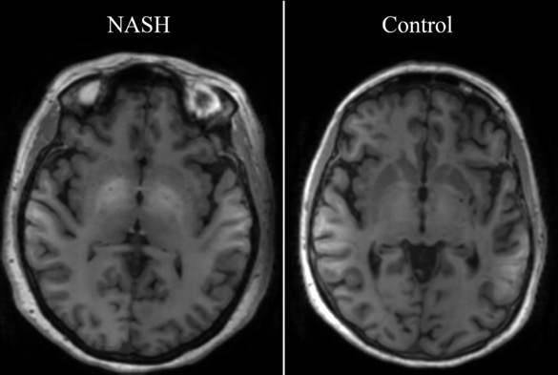

Figure 2: Normalized T1 SI of globus pallidus and putamen with respect to cerebral cortex, cerebral white matter and brainstem after adjusted for false discover rate

Figure 3: Signal intensity without normalization from four regions of interest: putamen (A), globus pallidus (B), cerebral white matter (C), and brainstem (D). p-values adjusted for false discover rate.

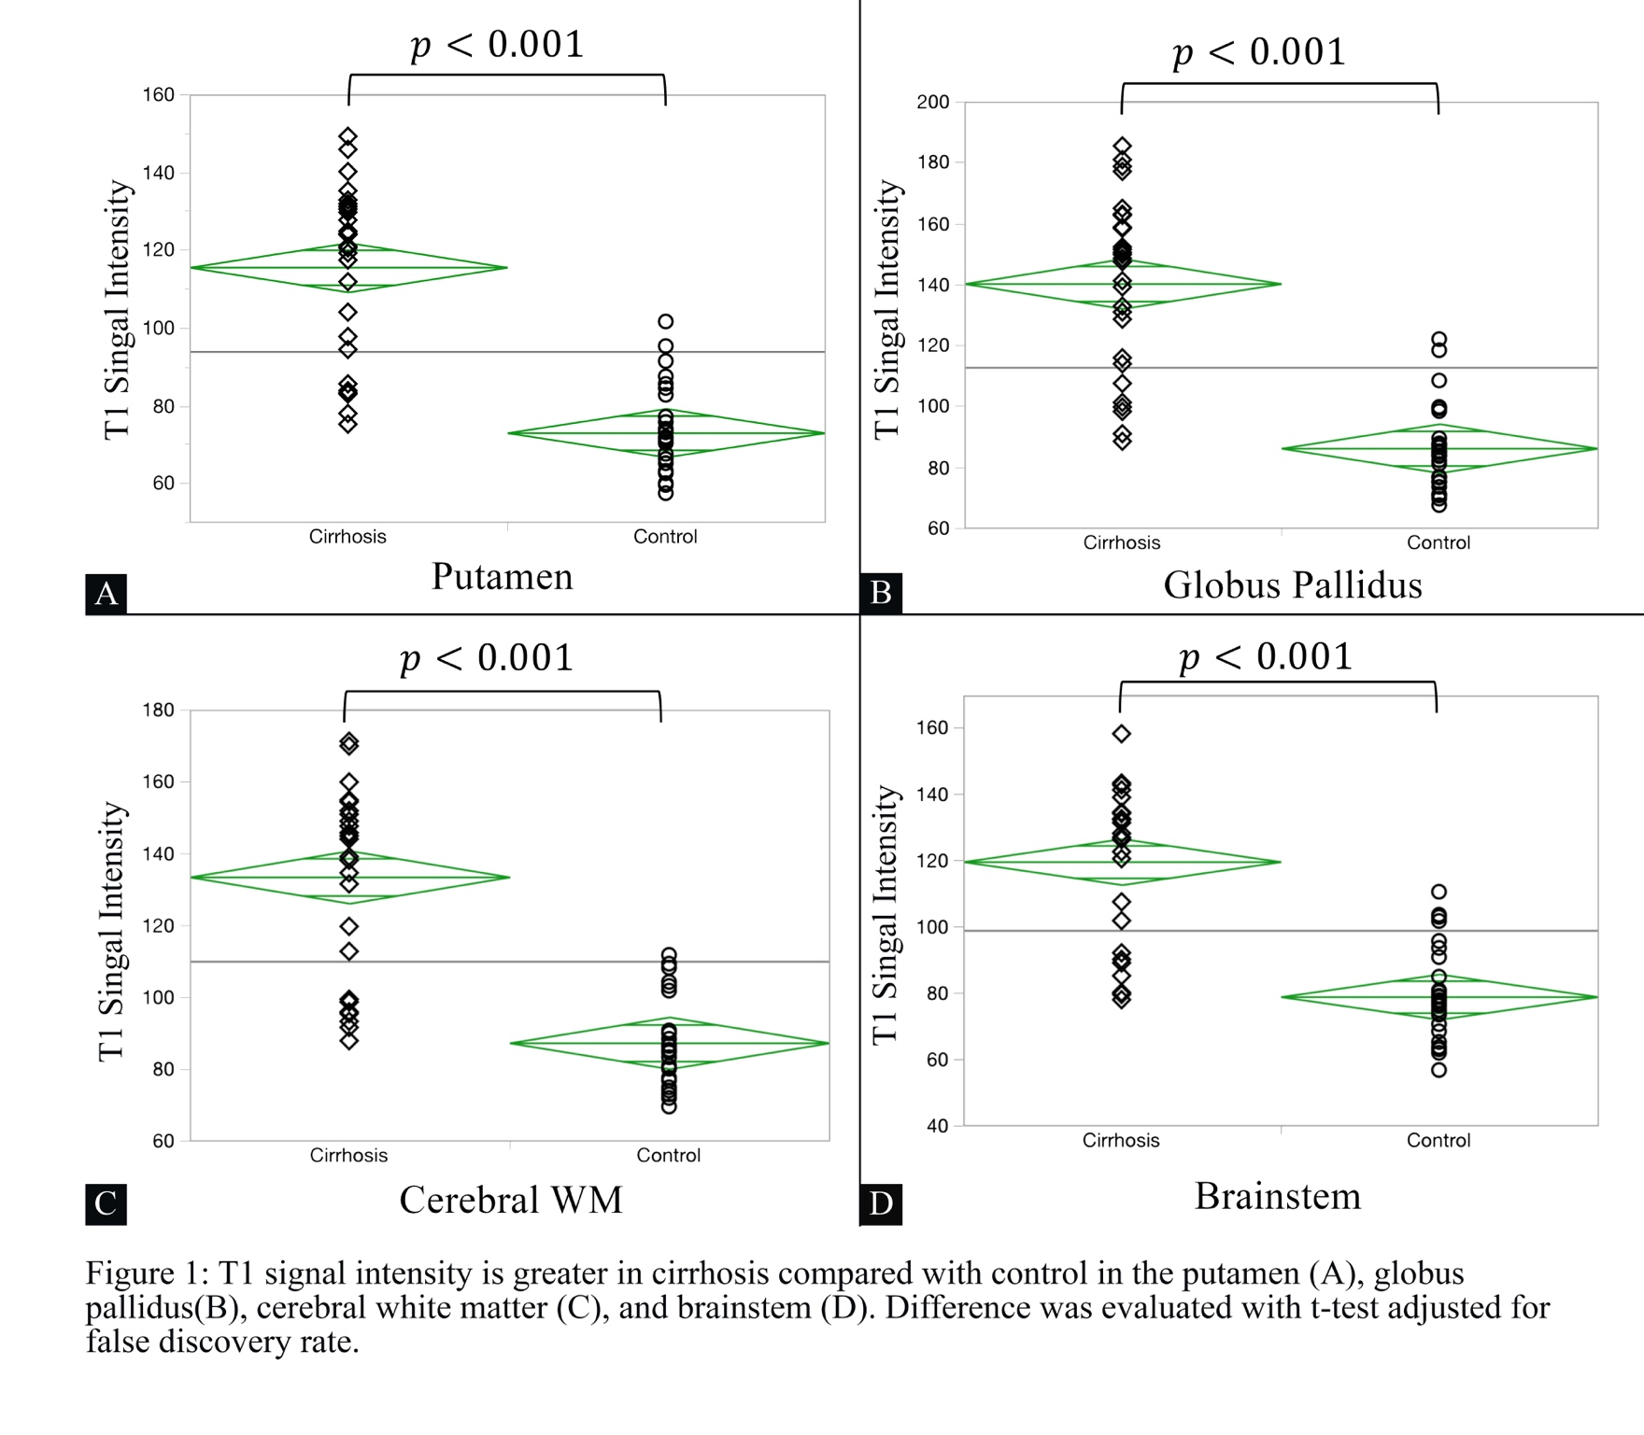

References:

1. Pujol A, Pujol J, Graus F, et al. Hyperintense globus pallidus on T1-weighted MRI in cirrhotic patients is associated with severity of liver failure. *Neurology.* 1993;43(1):65-69.

2. Vymazal J, Babis M, Brooks RA, et al. T1 and T2 alterations in the brains of patients with hepatic cirrhosis. *AJNR Am J Neuroradiol.* 1996;17(2):333-336.

3. Pinto RB, Froehlich PE, Pitrez EH, et al. MR findings of the brain in children and adolescents with portal hypertension and the relationship with blood manganese levels. *Neuropediatrics.* 2010;41(1):12-17.

4. Lockwood AH, Yap EW, Wong WH. Cerebral ammonia metabolism in patients with severe liver disease and minimal hepatic encephalopathy. *J Cereb Blood Flow Metab.* 1991;11(2):337-341.

5. Aldridge DR, Tranah EJ, Shawcross DL. Pathogenesis of hepatic encephalopathy: role of ammonia and systemic inflammation. *J Clin Exp Hepatol.* 2015;5(Suppl 1):S7-s20.

6. Krieger D, Krieger S, Jansen O, Gass P, Theilmann L, Lichtnecker H. Manganese and chronic hepatic encephalopathy. *Lancet.* 1995;346(8970):270-274.

7. Rose C, Butterworth RF, Zayed J, et al. Manganese deposition in basal ganglia structures results from both portal-systemic shunting and liver dysfunction. *Gastroenterology.* 1999;117(3):640-644.

8. Choy G, Khalilzadeh O, Michalski M, et al. Current Applications and Future Impact of Machine Learning in Radiology. *Radiology.* 2018;288(2):318-328.

9. Ashburner J, Neelin P, Collins DL, Evans A, Friston K. Incorporating prior knowledge into image registration. *Neuroimage.* 1997;6(4):344-352.

10. Dale AM, Fischl B, Sereno MI. Cortical surface-based analysis. I. Segmentation and surface reconstruction. *Neuroimage.* 1999;9(2):179-194.

11. Iwasa M, Kinosada Y, Nakatsuka A, Watanabe S, Adachi Y. Magnetization transfer contrast of various regions of the brain in liver cirrhosis. *AJNR Am J Neuroradiol.* 1999;20(4):652-654.

12. Tanenbaum LN, Tsiouris AJ, Johnson AN, et al. Synthetic MRI for Clinical Neuroimaging: Results of the Magnetic Resonance Image Compilation (MAGiC) Prospective, Multicenter, Multireader Trial. *AJNR Am J Neuroradiol.* 2017;38(6):1103-1110.

13. Kang KM, Choi SH, Hwang M, Yun TJ, Kim JH, Sohn CH. T1 Shortening in the Globus Pallidus after Multiple Administrations of Gadobutrol: Assessment with a Multidynamic Multiecho Sequence. *Radiology.* 2018;287(1):258-266.

14. Chalasani N, Younossi Z, Lavine JE, et al. The diagnosis and management of nonalcoholic fatty liver disease: Practice guidance from the American Association for the Study of Liver Diseases. *Hepatology.* 2018;67(1):328-357.

15. Choi JW, Moon W-J. Gadolinium Deposition in the Brain: Current Updates. *Korean J Radiol.* 2019;20(1):134-147.

16. Crombé A, Saranathan M, Ruet A, et al. MS Lesions Are Better Detected with 3D T1 Gradient-Echo Than with 2D T1 Spin-Echo Gadolinium-Enhanced Imaging at 3T. *Am J Neuroradiol.* 2015;36(3):501-507.

17. Reuter M, Schmansky NJ, Rosas HD, Fischl B. Within-subject template estimation for unbiased longitudinal image analysis. *Neuroimage.* 2012;61(4):1402-1418.

18. Maeda H, Sato M, Yoshikawa A, et al. Brain MR imaging in patients with hepatic cirrhosis: relationship between high intensity signal in basal ganglia on T1-weighted images and elemental concentrations in brain. *Neuroradiology.* 1997;39(8):546-550.